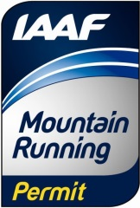 | WMRA Mountain Running  World Cup 2019  (21st edition)  APPLICATION FORM  (Appendix 1 to the World Cup Regulations) | 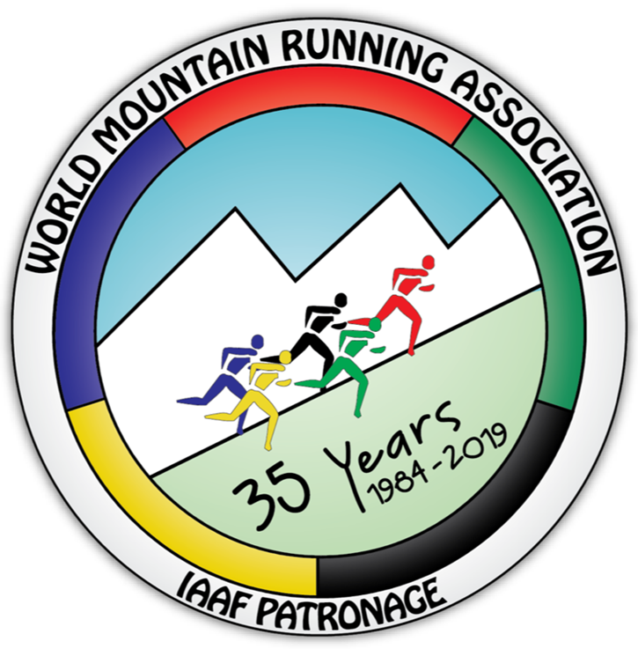

Name of federation: | Athletic Federation of
Address of federation:
Federation telephone: |  | e-mail: | @
We hereby submit our application to have the mountain race described below to be included in the Mountain Running World Cup Series for 2019 as set out in the regulations document:
http://www.wmra.info/files/regulations/World_Cup/WCup_2019_Regulations_-14Dec.pdf

NOTE:
- Making an applications for inclusion into the World Cup is free of charge.
- Applications may be sent via e-mail.
- A successful applicant will be then asked to sign the World Cup Contract (counter signed by the National Athletics Federation) agreeing to abide by the regulations and pay the World Cup fee (1700 EURO).

This application to be sent before 31.12. 2019 to:
- WMRA Secretary: Tomo Sarf, tomo.sarf@helios.si

WMRA Mountain Running World Cup 2019

Event data*
NAME of event |  |  |  | (edition / name)
DATE of event: |  | Possible alternative date:
VENUE - Place: |  |  | Country:
Web site:

ORGANIZER: |  |  |  |  | (name of the club)
Event director: | Name: |  | Address:
 | Phone:
 | e-mail:
Contact person 2 | Name: |  | Address:
 | Phone:
 | e-mail:

COURSE
Length |  | km
Total ascent |  | m
Total descent |  | m
Start: location, altitude |  |  | m
Finish: Location, altitude |  |  | m
Course type
Asphalted road |  | km
Macadam/4WD road |  | km
Mountain Path |  | km
Record times Men/Women |  | h:mm:ss (men) |  |  |  | h:mm:ss (women)
Record holder / year
Attachment: | course profile in as .doc or .xls file

Total race Prize money | Men: |  | EUR | Women: |  | EUR
1st prize |  |  | EUR |  |  | EUR
Awarded places (1 - ….)
Extra prizes

I declare that the above race details are correct and we declare that we have the support from our National Athletic Federation to join the WMRA World Cup.
Date: |  | Event director: |  |  | signature

* Please fill in the grey fields with computer!

