 | WMRA Mountain Running  World Cup 2021  (22nd edition)  APPLICATION FORM  (Appendix 1 to the World Cup Regulations) | 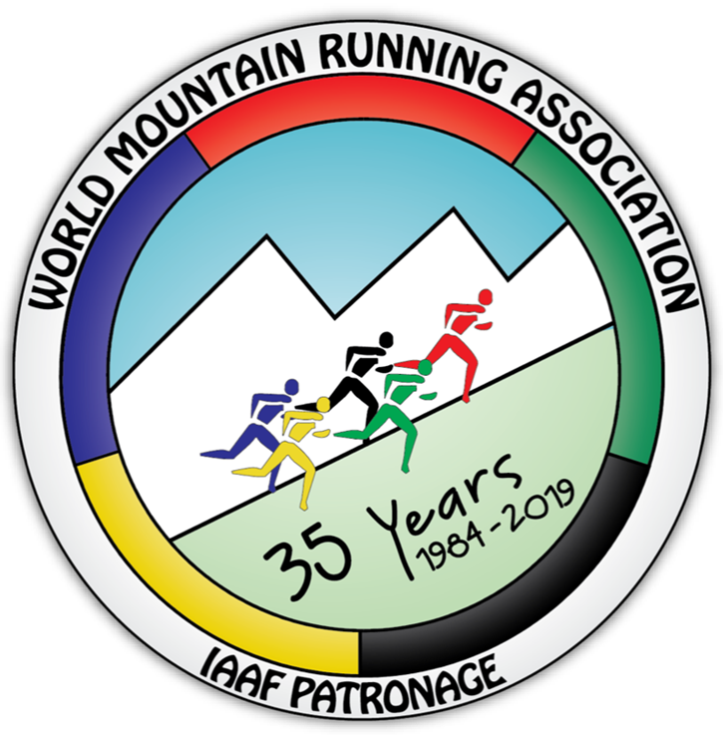

Name of federation: | Athletic Federation of
Address of federation:
Federation telephone: |  | e-mail: | @
We hereby submit our application to have the mountain race described below to be included in the Mountain Running World Cup Series for 2021 as set out in the regulations document: LINK

NOTE:
- Making an applications for inclusion into the World Cup is free of charge.
- Applications may be sent via e-mail.
- A successful applicant will be then asked to sign the World Cup Contract (counter signed by the National Athletics Federation) agreeing to abide by the regulations and pay the World Cup fee (3000 EURO for one race and 5000 EURO for two races in the event weekend).

This application to be sent no later than 30 October 2020 to:
- WMRA Secretary: Tomo Sarf, tomo.sarf@helios.si
- For questions relating to the application form please send them to the 2021 World Cup Manager: Jonathan Wyatt, jonospulse@yahoo.com

WMRA Mountain Running World Cup 2021

Event data*
NAME of event |  |  |  | (edition / name)
DATE of event: |  | Possible alternative date:
VENUE - Place: |  |  | Country:
Web site:

ORGANIZER: |  |  |  |  | (name of the club)
Event director: | Name: |  | Address:
 | Phone:
 | e-mail:
Contact person 2 | Name: |  | Address:
 | Phone:
 | e-mail:

Application is for 1 race category? Fee = 3.000 euro | Y / N
Application is for 2 race categories? Fee = 5.000 euro | Y / N

COURSE 1
(1 race category)
Length |  | km
Total ascent |  | m
Total descent |  | m
Start: location, altitude |  |  | m
Finish: Location, altitude |  |  | m
Course type
Asphalted road |  | km
Macadam/4WD road |  | km
Mountain Path |  | km
Record times Men/Women |  | h:mm:ss (men) |  |  |  | h:mm:ss (women)
Record holder / year
Attachment: | course profile in as .doc or .xls file

Total Course 1 Race Prize money | Men: |  | EUR | Women: |  | EUR
1st prize |  |  | EUR |  |  | EUR
Awarded places (1 - ….)
Extra prizes

COURSE 2  (2 race categories) | Do not use this table if applying for only one World Cup race in your event weekend
Length |  | km
Total ascent |  | m
Total descent |  | m
Start: location, altitude |  |  | m
Finish: Location, altitude |  |  | m
Course type
Asphalted road |  | km
Macadam/4WD road |  | km
Mountain Path |  | km
Record times Men/Women |  | h:mm:ss (men) |  |  |  | h:mm:ss (women)
Record holder / year
Attachment: | course profile in as .doc or .xls file

Total course 2 race Prize money | Men: |  | EUR | Women: |  | EUR
1st prize |  |  | EUR |  |  | EUR
Awarded places (1 - ….)
Extra prizes

Additional Travel Assistance offered for WMRA media/official team.

Additional Travel Assistance offered for invited runners. Please provide details of how many runners and level of travel assistance.

I declare that the above race details are correct and we declare that we have the support from our National Athletic Federation to join the WMRA World Cup.
Date: |  | Event director: |  |  | signature

If this application is approved then the World Cup Contract (to be signed by the National Federation / Organiser (LOC) / WMRA) will be sent to the LOC along with that confirmation.

* Please fill in the grey fields with computer!

